Rangers and Rovers Activities
Suchethana Rangers Team and Bapuji Rovers Crew
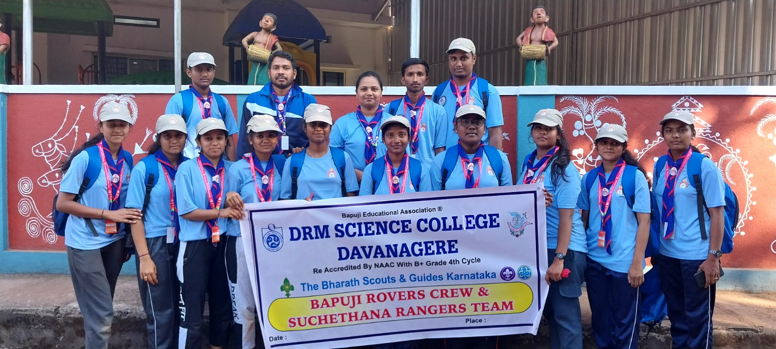

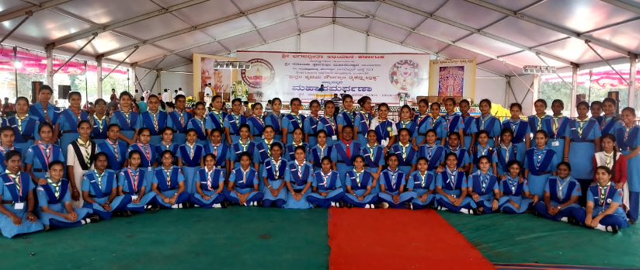
Active Participation of Rangers in Bhagavathgeetha Abhiyana

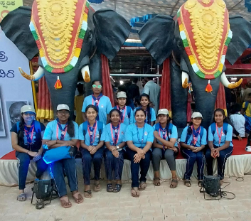
Rangers in Swadeshi Mela along with the Leader

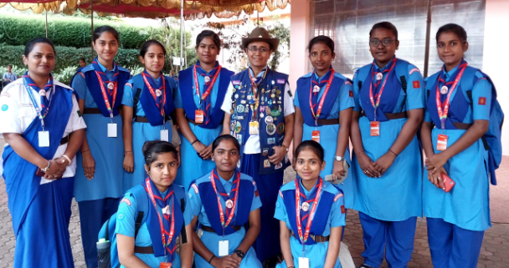
All Rangers and Ranger Leader with the Camp Chief Smt. Krupa
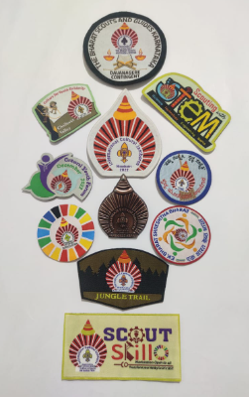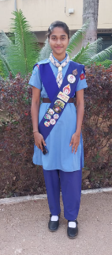

Earned Badges by Rangers at International Cultural Jamboree

